Javascript
Prepared: TrangNTT
Lab 11. Javascript 1
11.1. Array 2
11.2. Open new window 3
11.3. Count the Function calls 3
11.4. Set controls’ attributes 4
11.5. Add text fields 4
11.6. Validate PostalCode and Money (Regular Expression) 5
11.7. Exercise 1 - Event Handling 5
11.8. Exercise 2– Inheritance 5
11.9. Exercise 3 - DOM 6
11.10. Exercise 4 – Validate inputs 6

Note: Using Firebug to debug Javascript.

Array
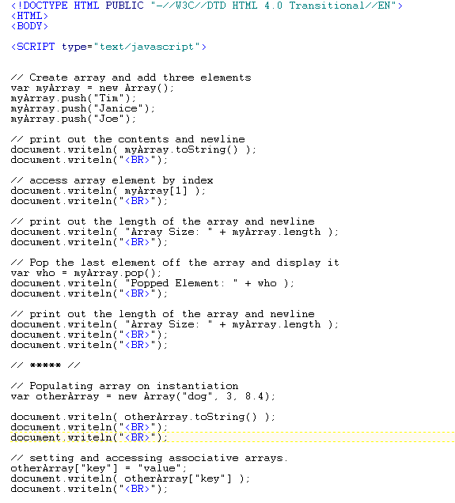
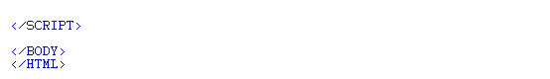
Result:
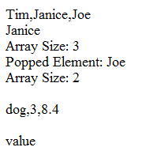

Open new window
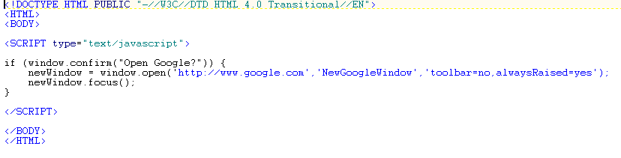

Count the Function calls
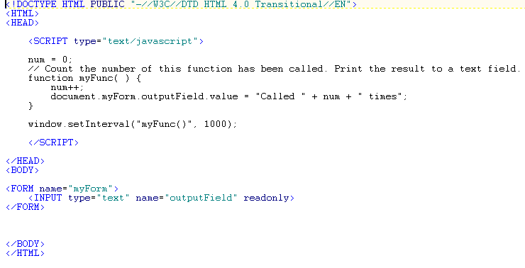

Set controls’ attributes
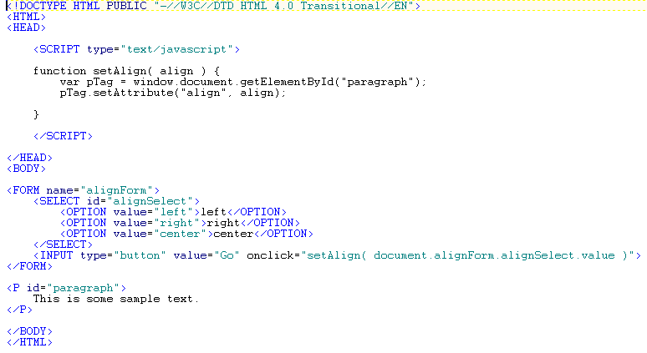

Add text fields
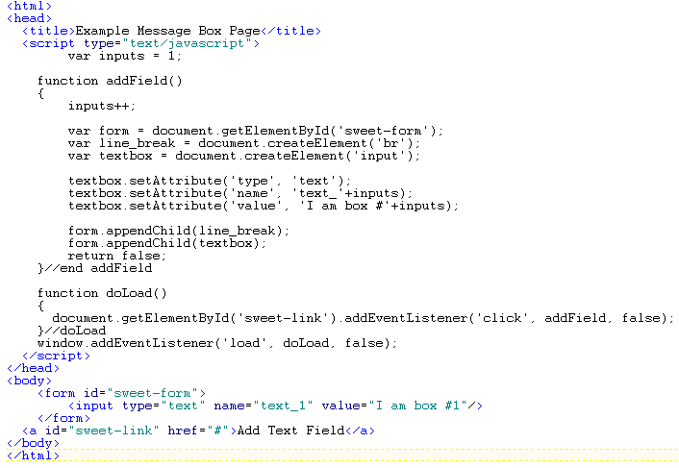

Validate PostalCode and Money (Regular Expression)
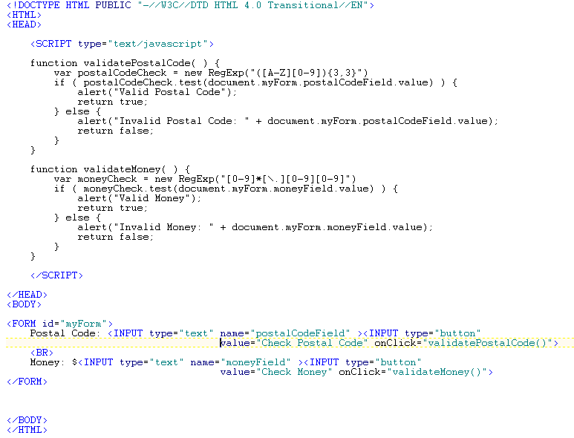

Exercise 1 - Event Handling
Write a simple HTML document called colors.html containing three colored links at the top of the page labeled RED, GREEN, and BLUE. Under the links there should be a small paragraph of text (you make this up) with a starting color of BLACK. Using onMouseOver and onMouseOut events of the links, when a user rolls over the each and any of the color labeled links, the color of the text in the paragraph below should change to the color corresponding to the link the user is hovering over. When the user rolls off the link, the color of the text should go back to it's starting color of BLACK.

Exercise 3 - DOM
Weight: 20/40
The purpose of this part of the assignment is to create a HTML document that enables a user to enter and save his/her favorite blog. The document consists of two separate frames. When the user fills out the form in right frame and submits it, the information submitted is saved in a cookie on the user's machine and the information is displayed in given fields in the left frame. If the user closes the browser window and re-opens the HTML document within twenty-four (24) hours, the information originally entered should still be displayed in the left frame because it will be stored in a cookie. Now suppose a user has a new favorite blog, therefore the user should be able to overwrite the existing information by simply entering new information into the form. Both the information in the left frame AND the cookie should be updated, so if the user re-opens the browser at a later time, only the most recent favorite blog is visible in the left frame.
You are provided with the following:
- index.html: The FRAMESET document.
- left.html: Where the user's favorite blog is displayed.
- right.html: Where the user enters the favorite blog.
You need to:
- Finish the addBlog() function in right.html to update the left frame and store the blog information in a cookie.
- Add whatever code is needed to left.html so that the appropriate cookie is retrieved and the blog information displayed when the frame is opened or refreshed.

Exercise 4 – Validate inputs
Create a register form and validate inputs in the form (username… not null, email, telephone in the right format…)

